**ADVANCED ARTIFICIAL INTELLIGENCE**

**SENTIMENT ANALYSIS – SENTIC COMPUTING FOR POLITICAL FORECASTING.**

**By-**

**Anisha Pathakamoodi (101101639)**

**Nishanth Chiluveri (101114949)**

**Chandana Korrapati (101073424)**

**Abstract:**

Sentiment analysis is also known as opinion mining. It entails a study of emotive text analysis, computational linguistics, and biometrics, as well as systematic identification, extraction, and quantification. Sentiment analysis basically done in a variety of domains, including detecting cyber issues such as hacking, political forecasting, and public opinion mining. We would want to employ sentiment analysis on political forecasting. The Political forecasting is based on the number and kind of political events, which include diplomatic choices, political leader activities, and other aspects of politics. We would examine the results of political events using sentiment analysis. We produce an uncontrollable emotion. By this, we want to develop a unique methodology geared to forecast and organize more comprehensive and effective systematic analytical efforts.

**Introduction:**

Analysis is used in all aspects like purchasing a product or a good from a store. People analyse it, so that they don’t get affected by the product. Basically, people judge a product based on the information provided by the manufacturer. As we know, every product is designed based on user’s requirements.

Sentiment analysis is a classification tool which is used to analyse a incoming message and gives the result whether the underlying sentiment is positive, negative or neutral. It is also procedure to determine if the chunk of text is positive, negative or neutral. The best example for this would be – Twitter. You would find a large amount of data, which is – Tweets. Now-a-days, People are getting addicted to the social media. In twitter, it is easy to reach anyone, and the effect of tweets are incredibly having a great impact on the society. So, to analyse the ratio of reaction of the people using twitter.

Sentiment analysis is basically a process of automates the mining of attitudes, opinions, expression of emotions based on the situation or issue that arise. Different people have different and unique opinions and unique way to reacting and responding to a problem and will find different ways to find different solutions. As every coin has two sides, every scenario has two categories to analyse which is positive and negative. Now-a-days, the upcoming generations are using social media to express their views and opinions on a particular incident. People mostly depends on the content that is generated over online for decision making.

As we all know, Politics is the major aspect in the society and also a hot topic in day-to-day life for every individual. The media channels are using the social media platforms to spread and create awareness to the people in regard to any issue that occurs in the society. Using sentiment analysis, we would be able to predict the results of the issue occurred. The idea is to extract sentiments of people towards their leaders to predict the results of the election.

**Importance of the approach:**

The main moto of this research is to analyse Machine learning methods (Naive Bayes, Support Vector Machines (SVM), deep learning (LSTM)) to retrieve the best accuracy. which incorporates emotional signals seen in social media discussions such as, emoticons and punctuation, as well as a strategy for incorporating this model to correlate sentiment changes. By this, we can develop a unique methodology geared to forecast and organize more comprehensive and effective systematic analytical efforts. Twitter is being chose as it contains a large amount of data and can analyse that allows to keep track of the incidents and will help in channelise the negative and positive comments.

**Related work/ Literature review:**

**Sentiment Analysis:**

The way people use information to make decisions has altered as a result of social media platforms. They frequently seek one another's opinions before making choices and judgments. Sentiment analysis in social media is a difficult topic that has sparked a lot of interest. The influence of sentiment analysis methods to extract meaningful information from unstructured data was explored by the authors. with applications ranging from appraising consumer products, services, healthcare, and financial services to analysing social events and political elections. Sentinel, a concept-level sentiment analysis system with 100,000 concept entries, was introduced by Cambria. Sentinel serves as a semantic link between emotion at the idea level and natural language data at the word level. Following each notion are five aliased semantic nodes.

**Proposed Methodology:**

In this section, we would want to describe the methodology we used, Machine learning methods (Naive Bayes, Support Vector Machines (SVM), deep learning (LSTM)) to retrieve the best accuracy and can be considered as baseline learning methods to develop our model. Demonstrating that it comprises of a series of processes ranging from the extraction of twitter user messages to the election prediction process. The guidance has an impact on our work. We used sentiment analysis in our research, as well as an attempt to bias data by picking only influential communications, rather than depending solely on volume (the number of messages the candidate receives).

Media uses poling system to predict the results of the election in people’s point of view. We have gathered large amount of data from twitter using API. Later we have pre-processed the data using removal of URL, unused words, by eliminating the special characters and duplication of tweets. By gathering the information, we have sorted the data by counting the number tweets extracted using top words, favourite, and retweet. We have extracted the data, which is based on the tweets received for the issue caused (i.e.) positive, negative, and neutral reviews.

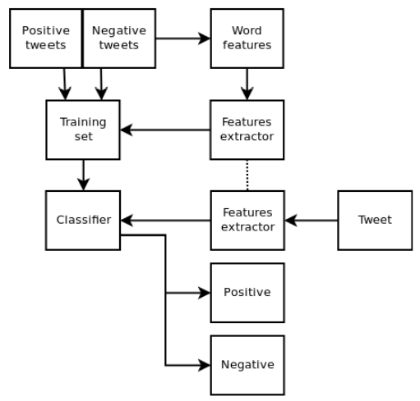

**Results:**

| **Algorithm** | **Accuracy** | **Dataset Size** |
| --- | --- | --- |
| SVM | 85.47 | 1,62,981 |
| Naive Bayes | 74.25 | 1,62,981 |
| LSTM (20 epochs) | 83.71 | 14,000 |

Conclusion:

We present a survey and comparison of existing strategies for opinion mining. As we used Machine learning methods (Naive Bayes, Support Vector Machines (SVM), deep learning (LSTM)) to retrieve the best accuracy and can be considered as baseline learning methods to develop our model and the performance is also good. After all the training and testing, we get that the accuracies of sentiment analysis are 74.25% (Naive Bayes) and 85.47%(SVM). We can see from the result that the accuracy of SVM is better than Naive Bayes. Other side SVM, Naive Bayes and LSTM was quite effective. If we have deduced more clear data, we could have retrieved the more accurate results.

References:

* Po-Wei Liang, Bi-Ru Dai, “Opinion Mining on Social MediaData", IEEE 14th International Conference on Mobile Data Management,Milan, Italy, June 3 - 6, 2013, pp 91-96, ISBN: 978-1-494673-6068-5, http://doi.ieeecomputersociety.org/10.1109/MDM.2013. >
* Pablo Gamallo, Marcos Garcia, “Citius: A Naive-Bayes Strategyfor Sentiment Analysis on English Tweets", 8th InternationalWorkshop on Semantic Evaluation (SemEval 2014), Dublin, Ireland,Aug 23-24 2014, pp 171-175. >
* Neethu M,S and Rajashree R,” Sentiment Analysis in Twitter using Machine Learning Techniques” 4th ICCCNT 2013,at Tiruchengode, India. IEEE – 31661
* Tumasjan, A., Sprenger, T. O., Sandner, P. G. & Welpe, I. M. Predicting elections with Twitter: What 140 characters reveal about political sentiment. In *ICWSM 2010—Proceedings of the 4th International AAAI Conference on Weblogs and Social Media* 178–185 (2010).
* DiGrazia, J., McKelvey, K., Bollen, J. & Rojas, F. More tweets, more votes: Social media as a quantitative indicator of political

behavior. *PLoS ONE* **8**, e79449 (2013).